Take Two
Read a sequence of integers, given on a single line separated by a space.
Finds all unique elements, that are in range [10, 20] inclusive and print only the first 2 elements.
If there are fewer than 2 elements, print as much as there are. If there are no elements, print nothing.
Examples
Input | Output
15 2 15 14 12 | 15 14
17 -2 3 | 17
-2 3 | (no output)
Hints
Read the input and parse the strings to a list of numbers:
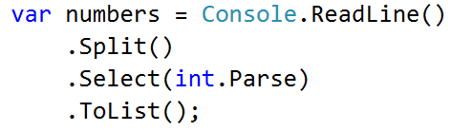
Filter the numbers with Where() and lambda expression, take the unique ones with Distinct(), take only two from the collection with Take() and iterate over them while printing with ForEach():
